SMART SENSORS

The Most Advanced Digital Sensor Ever Designed

At the heart of Enlighted’s IoT solution sits our patented, software-defined smart sensor that monitors real time occupancy, light levels, temperatures and energy usage, among other things. Only our sensors can distinguish between people and objects, customize controls for specific tasks, leverage ambient light and much more.

Unmatched Coverage for Data Collection

Enlighted sensors are deployed with LED lighting fixtures, one sensor per light, with a typical coverage area of 100 square feet. This makes the data collected very granular and rich. And because the sensors are attached to the lighting, they are ubiquitous throughout a building.

Proven, Flexible Wireless Network

All of our sensors are interconnected with an industry-leading, scalable wireless network; sensors communicate with one another or with Enlighted’s Cloud infrastructure, via a secure and robust wireless connection.

ENERGY SAVINGS

* Task tuning and high-end trimming
* Daylight harvesting
* Occupancy/vacancy detection
* Auto and advanced demand response programs
* Time-of-day dimming schedule
* Real-time energy savings report

COMFORT & CONVENIENCE

* Advanced occupancy detection
* Light-level stability
* Configurable dim-and-linger occupancy
* Personalized setting profile
* Stay-with-me lighting effect
* Fixture outage report

The Enlighted System. How it Works

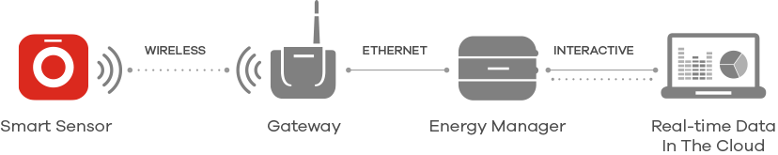

THE SMART SENSOR

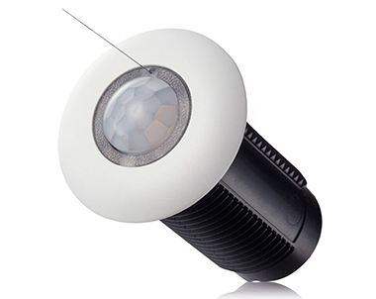

Enlighted Digital Sensors. Clearly Better.

* Highly advanced digital sensors that are intelligent, flexible, compliant
* One sensor per light for most optimal energy efficiency
* 4 sensors in one: temperature, light, IR and power
* 3 digital signal processors create unique profiles
* Most advanced wireless sensor network